Link: <https://crackmes.one/crackme/5e604d4333c5d4439bb2dd72>

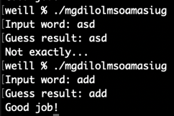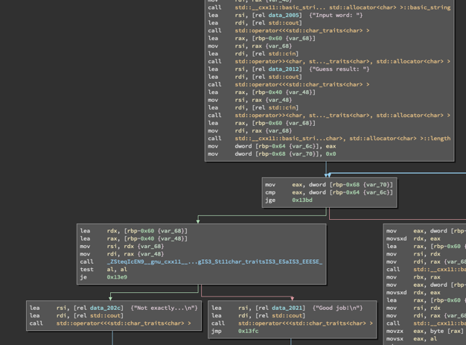

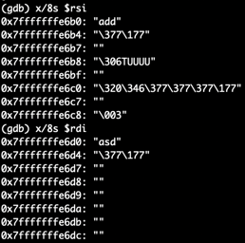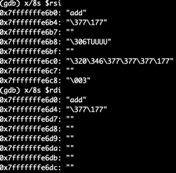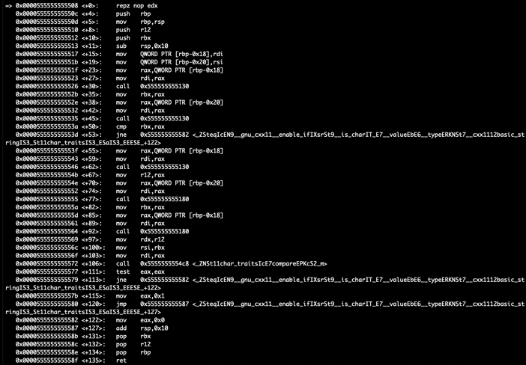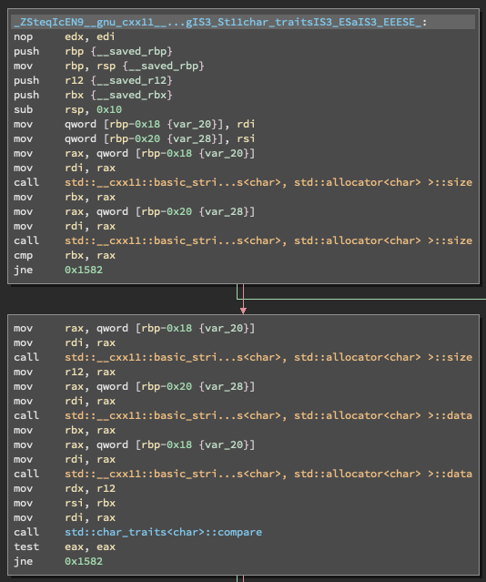Through static analysis of the code, I noticed the program calls a function that has an extremely long name. In this function a std::compare is called to compare the two inputs. I then used gdb to find out what exactly was being compared. A breakpoint was set at main, at the instruction before the function call and right before the compare. The addresses of the latter two breakpoints were obtained by viewing the disassembled code. The two inputs entered were "asd" and "asd". Going to the third breakpoint, rsi contained "add" and rdi contained "asd". Then I reran the program with the inputs "add" and "add". This succeeded. No flag was outputted, but an output of "Good job!" was printed.